SIMATS ENGINEERING
ASSESSMENT TOOL 2 (AT2)
COURSE NAME: INTERNET PROGRAMMING | COURSE CODE: CSA43
CO-1: Develop well-structured, standards-compliant web pages using HTML/XHTML and XML (L2)
Weightage: 20% | Total Marks: 20 Marks
Student Name: Y.Sai Mohith | Register Number: 192372210
Assessment Tool: Data Interpretation (Medium) | Status: Submitted & Verified

Question 1: HTTP Response Analysis
Scenario: Web server returns HTTP response header:
HTTP/1.1 200 OK
Date: Mon, 01 Apr 2026 10:00:00 GMT
Content-Type: text/html
Content-Length: -150
Connection: keep-alive

1.1 Identify any incorrect or invalid fields in the header.
• Invalid Content-Length: -150. Content-Length MUST be a non-negative integer (>= 0).
• Missing charset declaration in Content-Type (should be text/html; charset=UTF-8).
1.2 Analyze the issue with Content-Length and explain its impact.
In persistent connections (keep-alive), Content-Length tells the client where the body ends. Negative numbers break socket stream framing, triggering parse exceptions (ERR_INVALID_HTTP_RESPONSE) or HTTP Request Smuggling vulnerabilities.
1.3 Determine whether the status code matches response correctness.
Status code 200 OK asserts successful delivery, which contradicts a malformed protocol header. The server should return 500 Internal Server Error if header framing fails.
1.4 Suggest corrections for the identified errors.
HTTP/1.1 200 OK
Date: Mon, 01 Apr 2026 10:00:00 GMT
Content-Type: text/html; charset=UTF-8
Content-Length: 150
Connection: keep-alive

Question 2: DOM Structure Analysis
Scenario: Consider DOM tree representation:
<html>
<head>
<title>TestPage</title>
</head>
<body>
<div>
<p>HelloWorld
</div>
</body>
</html>

2.1 Identify missing or improperly closed elements.
• Missing <!DOCTYPE html>, unclosed <p> tag, missing lang="en", and charset meta tags.
2.2 & 2.3 Browser parsing interpretation & rendering impact.
HTML5 parsers auto-close <p> before </div>, yielding <div><p>HelloWorld</p></div>. Missing DOCTYPE triggers Quirks Mode, causing legacy box-model calculation shifts and CSS margin inconsistencies.
2.4 Suggest corrections to make the DOM valid.
<!DOCTYPE html>
<html lang="en">
<head>
<meta charset="UTF-8">
<title>TestPage</title>
</head>
<body>
<div><p>HelloWorld</p></div>
</body>
</html>

Question 3: GET vs POST in Login System
GET appends credentials to URL (/login?user=admin&pass=1234), exposing passwords in history and logs. POST encapsulates credentials in HTTP message payload body over encrypted HTTPS.
Question 4: HTML Code Inspection
Missing closing tags </h1>, </p>, and missing required alt attribute on <img> tag. Unsized images cause Cumulative Layout Shift (CLS).
<!DOCTYPE html>
<html lang="en">
<head><meta charset="UTF-8"><title>Sample</title></head>
<body>
<h1>Welcome</h1>
<p>This is a paragraph</p>
<img src="image.jpg" alt="Descriptive image text" width="600" height="400" loading="lazy">
</body>
</html>

Question 5: Browser-Server Communication Flow
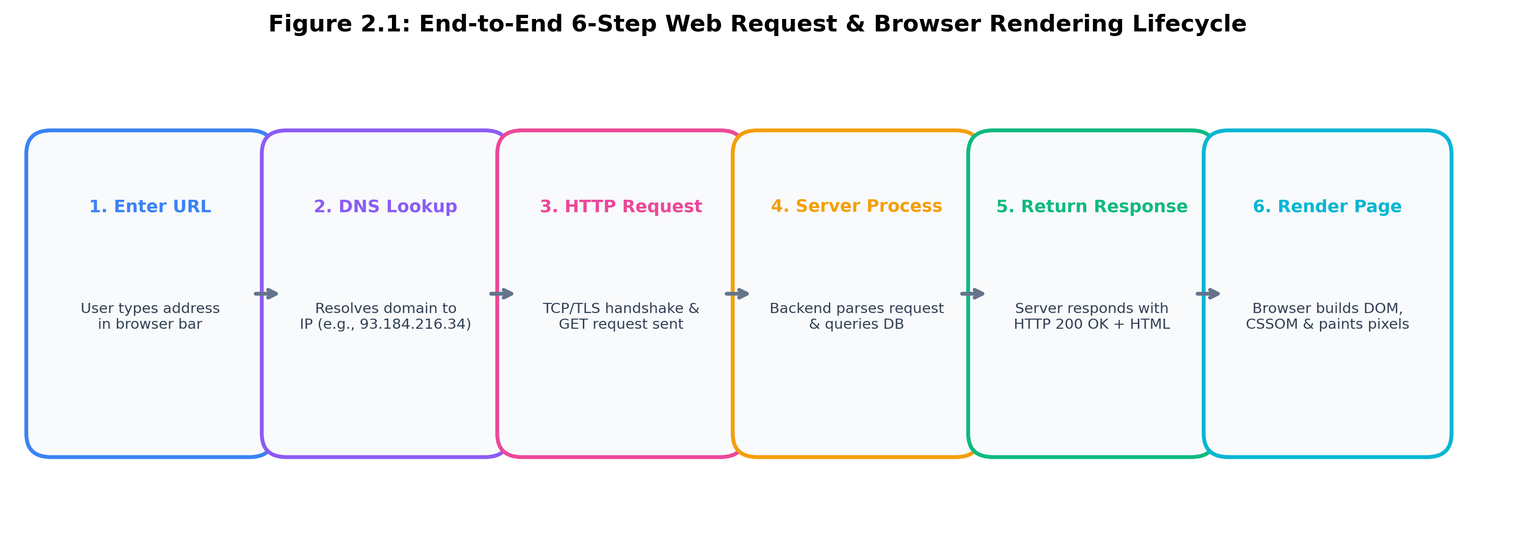
1. Enter URL -> 2. DNS Lookup -> 3. HTTP Request -> 4. Server Processing -> 5. Response Returned -> 6. Browser Renders Page.
Delays occur in uncached DNS resolution, high RTT TLS handshakes, slow server DB queries, and render-blocking CSS/JS.

Code of Conduct:
I, Y.Sai Mohith (Reg No: 192372210), certify that this submission is my original work and that I have adhered to the guidelines specified for this assessment. I understand that any violation of academic integrity rules will result in disciplinary action.
Signature of the student: Y.Sai Mohith (192372210)

